LAB 4
OBJECT: -
Create an ASP Application that validates users from database.
THEORY: -
CONNECTION WITH DATABASE: Requirements: -

1.ADODB
a. Connection: used to connect to the database.
b. Recordset: used to retrieve records from the connected database.
2. ConnectionString
a. For MSAccess: "Provider = Microsoft. Jet. OLEDB.4.0; Data Source=
database_path; Persist Security Info = False”
b. For SQL Server: "Driver = (SQL Server); Server = server_ name; UID =
User_ Name; PWD = Password; Database = Database__Name "
3. open the connection.
4. SQL to retrieve data.
5. open the recordset with SQL and connection.

PROCEDURE:DESCRIPTION: -
The exercise consists of two pages and a SQL Server Database:

- Login.asp: used to take inputs (using input tag having type text and password) and submitting that inputs (using input having type submit) that can be used onto the next page (navigated using the action property of the form tag).
- LoginValidation. asp: used to validate user by database values print message either the login is successful or unsuccessful
- dbLogin: database created in SQL Server.

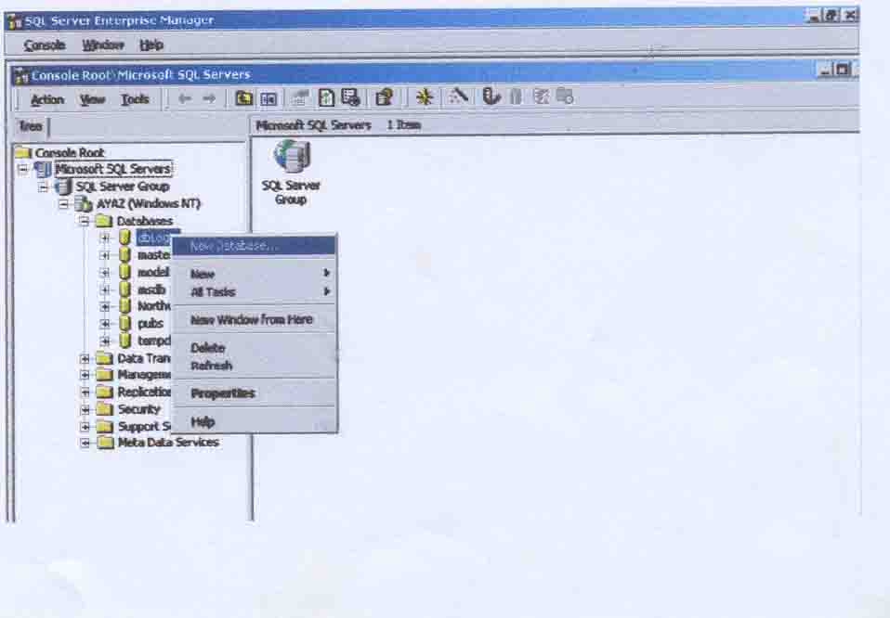
Database Creation: -

1. open Enterprise Manager
in Microsoft SQL Server.
2. Right click Databases and
click New Database.

